1) **A** Pi Day is observed on March 14 of every year.

2) **A** The circumference of the circle is π so  . Solving for the radius  gives us  . The area of the circle is given by  .

3) **C** The first 6 digits of pi after the decimal are 3.141592...

 .

4) **E** The volume of a cylinder is given by  . The radius is 2 in. and the height is 5 in. so  . Thus each cup can hold 20π cubic inches.

5) **D** The triangle inequality says that for a triangle with side lengths , then . From this we can see that the last side length is bounded by . However, there are an infinite number of numbers between 1 and 5 exclusive.

6) **A**

7) **C** The rectangular booth need 6*8 = 48 square feet of

space. The booth also needs a 2 feet clearing from all points

on the booth, meaning it will need a 2 ft. wide rectangle of

8 ft.

space from its sides and a quarter circle with radius 2 ft. of

6 ft.

space from each of its corners, as shown in the diagram.

Thus, the booth needs  of

additional space, or square feet of extra space.

2 ft.

Therefore, the booth needs square

feet of space.

8) **D** The round trip to the store is miles long. However, because Michael had to go back and get something when he was one-third of the way to the store, he biked an additional miles. Therefore, Michael biked miles. Using the formula distance = rate * time, . Solving for t gives hr. We wish to have t in minutes so .

9) **C** If the dimensions of the sides are increased by 50%, then the sides are multiplied by a factor of . If the sides of a figure are multiplied by a factor , then the area of the figure is multiplied by . Thus the area of the new banner is .

10) **D** The supplement of the supplement of an angle gives the angle itself (). Thus we are finding the supplement of the complement of . The complement of  is . The supplement of  is 

2 in.

11) **E** Find out the lengths of the sides of the square included in

the perimeter of the figure by subtracting the parts of the sides

covered by the circles. The circles each have a perimeter that is 

of the actual circle. Thus, the perimeter of the figure is

5 in.

5 in.

.

8 in.

12) **A** We know from the given equation of the circle that  ,  , and  .  .

13) **D** Only the contrapositive is logically equivalent to the conditional statement in all cases. Choice D is the only one that satisfies this.

10 in.

14) C In order for the discus to land completely inside the piece of paper,

the center of the discus must be at least 1 inch from any side of the paper.

6 in.

Thus, the center of the discus can land in a 6 in. by 8 in. rectangle in

order for the discus to be completely in the sheet of paper. Thus, the

8 in.

probability that the discus lands completely inside the paper is given

8 in.

by .

15) **C** Let the angles be , , and . The angles of a triangle must add to  so . One of the angles of the triangle is  so . Thus the angles are , , and . The largest angle is .

16) **A** The spool has a radius of  in. so the spool has a circumference

of in. If the spool is unwound 150 times to unwind all of the string,

25 ft.

the string has a length of in. or ft. The height the kite

flies at is perpendicular to the ground so we can use a right triangle and the

Pythagorean Theorem to solve for the ground distance to the kite. Setting

20 ft.

the length of the string as the diagonal and the altitude of the kite as the vertical

leg, we get that . Solving for the positive value of x, we see that

. Thus, the ground distance to the kite

x ft.

is 15 ft.

17) **A** If a circle has an equal value for its area and circumference, then . Solving for , divide both sides by to get . Thus, the radius is 2 and the answer is choice A.

18) **C** Let the number of digits Nilay recited be . In terms of , Sarah recited digits, Sampath recited digits, and Arya recited digits. The sum of the interior angles of a decagon is . Thus, 

. Solving for  gives . Therefore the sum of the number of digits Arya and Sampath recited is

.

A

B

C

D

E

F

19) **D** Draw the line parallel to BF going

through C. Label a point X as shown.

Since BF and CX are parallel, 

X

. Since CX and DE are

parallel, . Thus





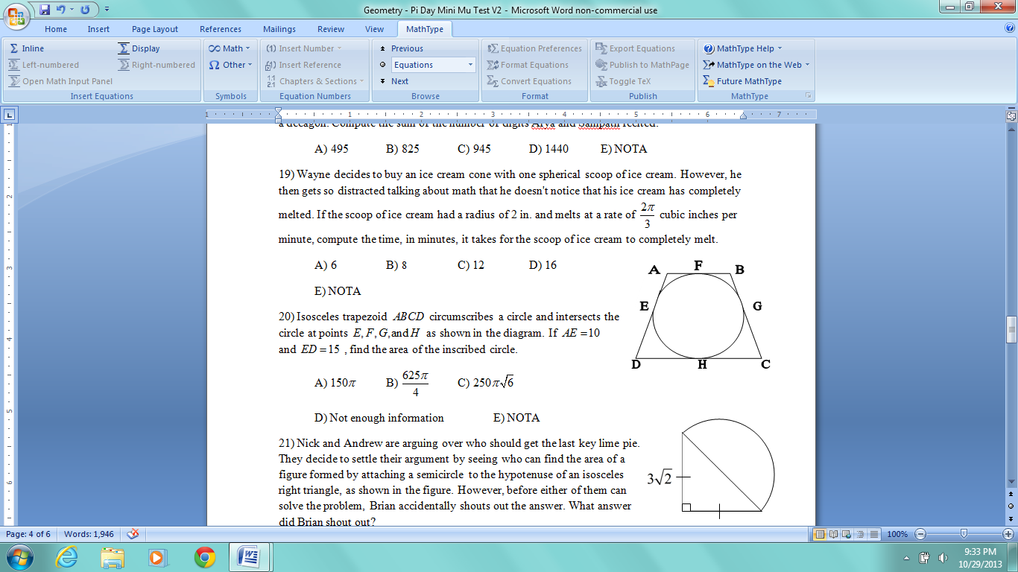

20) **C** Note that tangents to a circle from the same point have

equal lengths. Therefore,  and .

Drop a perpendicular line from  to and call the point

of intersection . Notice thatand .

Since  and ,

we can use the Pythagorean Theorem to solve for the length

of . . Since and

 is the diameter of the circle, the radius of the circle is 6. The area of the circle therefore is .

21) **D** The legs of an isosceles right triangle are congruent so each leg has a length of .

The hypotenuse of the right triangle thus has a length of . Since the hypotenuse of the right triangle is also the diameter of the semicircle, the semicircle has a radius of . The area of the figure is the sum of the areas of the right triangle and the semicircle. The right triangle has an area of  and the semicircle has an area of . Thus, the sum of the areas of the two figures is .

22) **A** The measure of is . The exterior angle of C is the supplement of or . The supplement of the exterior angle of C is . Taking the complement of , we get . Finally, taking the supplement of , we get .

23) **B** An analog clock has 12 numbers so the number of degrees between each number is . Thus, the number of degrees between the 12 and the 3 on the clock is . However, at 12:15, the hour hand is the way from 12 to 1 so we must subtract of from . Thus, the angle between the hands at 12:15 is .

24) **B** Since the pie is 2 in. deep, the radius of the base is in. Thus the pie Nick received has a volume of cubic inches. Since Nick gave  of the pie to Andrew, Andrew received cubic inches of the pie.



25) **E** Call the radius of the quarter circle x and call the radius

of the semicircle y. The perimeter of the quarter circle is given



by and the perimeter of the semicircle



is given by . Since the perimeters of the



2 figures are equal, . We want the ratio of the



radius of the quarter circle to the radius of the semicircle, or the

quantity . We can manipulate the equality by dividing both sides by y and both sides by 

to get .

26) **C** A cyclic quadrilateral (a quadrilateral inscribed in a circle), has the property that angles on the opposite side of one another (e.g.  or ) are supplementary. Thus is the supplement of and .

27) **D** The coordinates of point C are . Since  is a right angle, the line running through points A and B and the line running through points B and C are perpendicular. The slope of the line through points A and B is . Thus, the slope of the line through points B and C is . Using the definition of the slope, . Solving for y gives .

We want the ordinate or the y-coordinate of point C, which is 11.

28) **E** The interior angles of a hexagon sum up to . Let the smallest angle have an angle measure of . Thus, putting the other angles in terms of the smallest angle, the sum of the interior angles of the hexagon is . Solving for , . Thus, the smallest angle of the hexagon has a measure of . We want the measure of the largest angle, so . Thus the answer is E.

29) **C** The surface area of the pie is , thus the radius of the pie is 5 in. Since the outer rim is 1 in. wide, the inner area of the pie is a circle with radius 4 in. Thus, the area of the outer rim = surface area of the pie - inner surface area of the pie. Therefore, 

30) **B** π is a real number so I is false.

π is irrational so II is true.

π is not a natural number so III is false.

Only statement II is true.